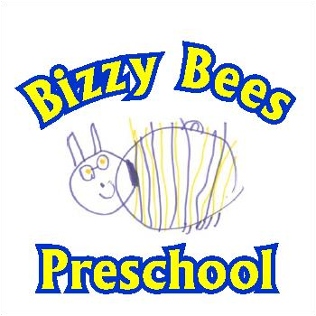

Preschool Information Pack
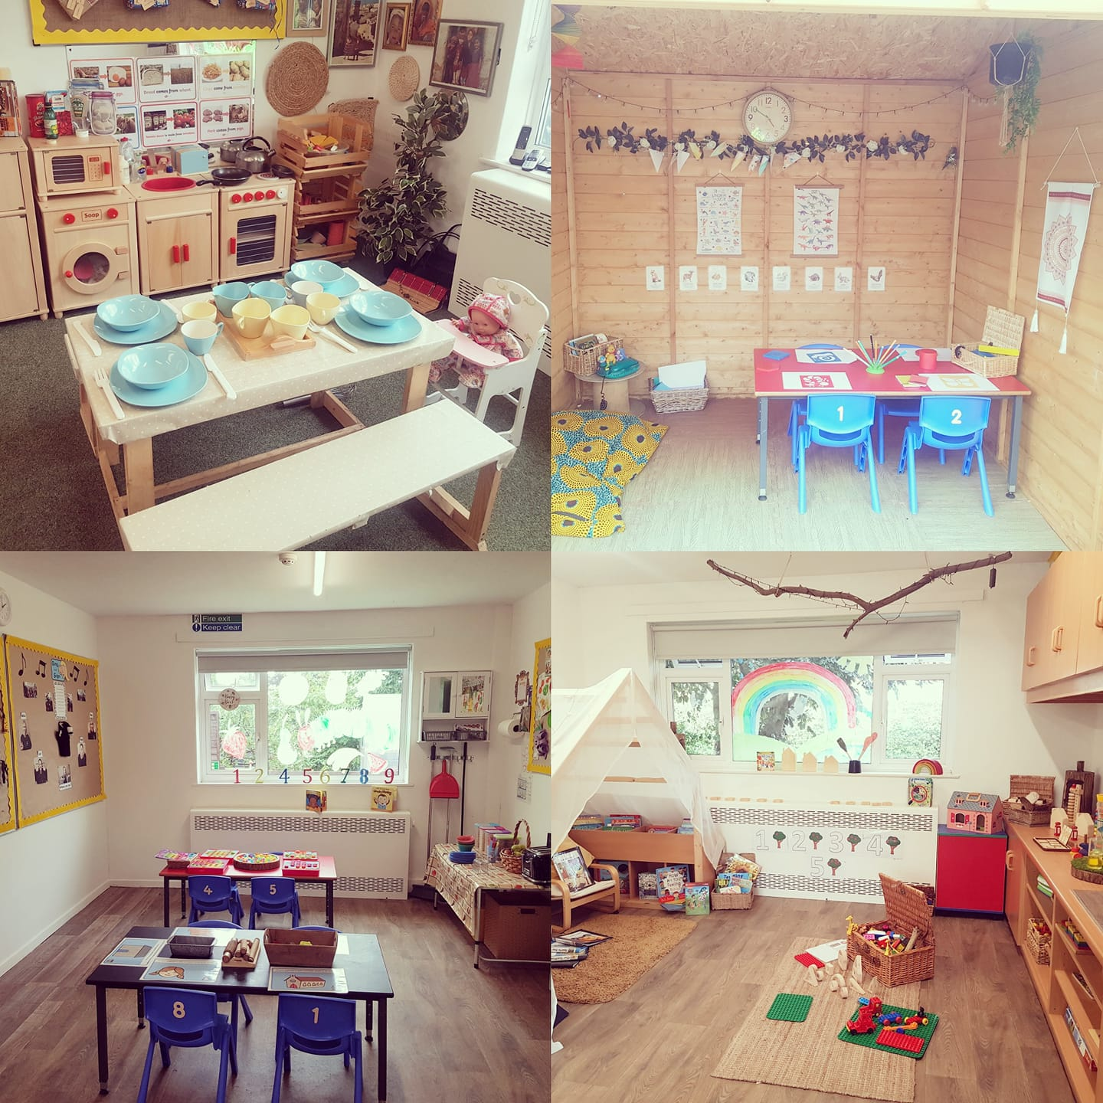
The Bungalow
Broomfield C.P. School
Off Ploughmans Lea
East Goscote
Leicestershire
LE7 3ZQ
Bizzy Bees Proprietor: Rachel Laverty: 07908781652

Bizzy Bees Staff and their Roles
Rachel Laverty
Pre School Manager/Proprietor
NVQ level 3 in Childcare Learning and Development
Level 3 Early Years Communication Professional
Sendco – EY SENDCO Professional Qual
Designated Safeguarding Lead
Health & Safety Coordinator
First Aider
Data Protection Officer
Level 2 Food Hygiene
SENDCO

Lisa Cammish
Deputy Manager
NVQ Level 3
NVQ Level 2
Food safety Coordinator
First Aider
Safeguarding
Level 2 Food Hygiene
SENDCO

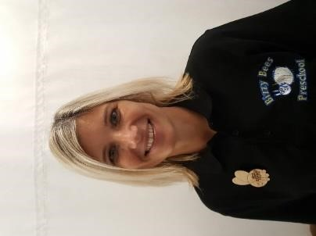
Sarah Brown
Preschool Educator
NVQ Level 3
First Aider
Level 2 Food Hygiene
Behavioural Coordinator

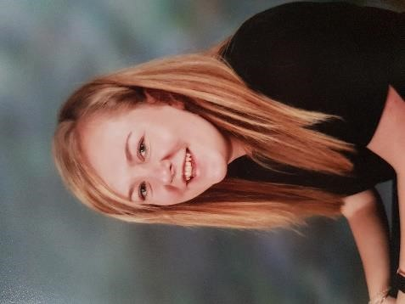
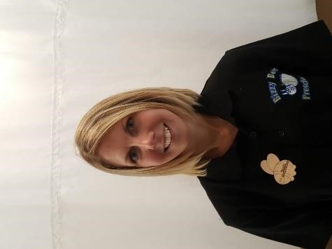

Frankie Hagyard
Assistant Deputy
NVQ Level 3

First Aider

Food Hygiene Level 2

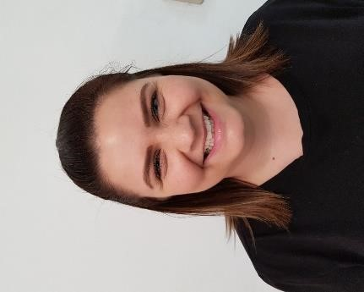
Kelly Moore
Preschool Educator

NVQ Level 3

First Aider
Food Hygiene Level 2
Rachel Love
Preschool Assistant

First Aider
Food Hygiene Level 2

Rhea Hadley
Preschool Assistant

Working towards NVQ 3

First Aider
Food Hygiene Level 2
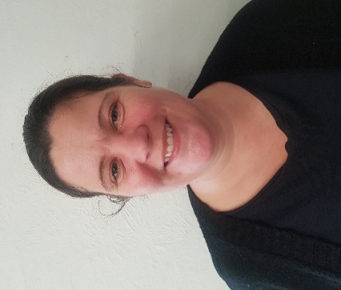
Claire Obsorne
Preschool Educator

BA Hons in Education Studies – Specialising in EYFS

First Aider
Food Hygiene Level 2

Introduction to Bizzy Bees Preschool
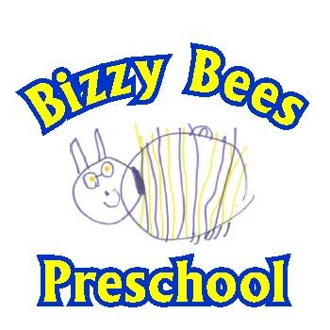

Bizzy Bees Preschool operates from the Bungalow located in the grounds of Broomfield Primary School. We accept children from the local community and villages/towns further afield. We offer a choice of 3 sessions these are, 9am-3pm, 9am-12pm and 12pm-3pm, Monday, Tuesday, Wednesday, Thursday and Friday during term time. Children are welcome from the age of 2 to their entry into their chosen School, dependant upon vacancies. We also have a breakfast club available from 8am.
The group’s daily capacity is 26 children and staffing will depend upon the cohort of ages each day, where for 2 year olds a 1:4 ratio of adults to children
is applied and for 3/4 year olds a 1:8 ratio is applied as a minimum requirement, due to our fabulous free flow arrangement we are always over staffed with regards to the ratio with at least 5 staff members at one time.

Mission statement

We are committed to providing a happy, stable and importantly, a loving environment that enables each and every child to learn and develop to their full potential. Bizzy Bees is a friendly Pre-School run by qualified; experienced and
dedicated staff who are committed to the quality care and early education of the children, showing understanding when responding to the needs of each individual child.

AIMS AND OBJECTIVES
At Bizzy Bees Pre-school we aim………………………………………………………..

- to provide a safe, secure, challenging, stimulating, caring and sharing environment which is sensitive to the needs of each child.

- to enhance each child’s curiosity, motivation and independence through sensitive support and stimulation of adults.

- to use and value what each child can do as a starting point

- to regularly assess each child’s needs and help them to develop.

- to value, support and extend the child’s language

- to allow opportunities for discovery and freedom to learn from experiences.

- to provide the supervision needed to offer encouragement and support.

- to enable choice and decision making

- to foster independence and self-confidence

- to build a child’s self esteem

- to involve parents/carers and value their contribution

- to ensure that we take due regard of a child’s religious persuasion, racial origin and cultural and linguistic background

- to provide inclusive experiences, where possible, for children with special educational needs

- to foster personal, social and emotional well-being

- to promote positive attitudes to learning

Settling In

We do recognise that starting Preschool is a big step in your child’s life and we will do all we can to help them feel welcome and settle-in recognising that every child and their experiences can be different.
We advise that you come with your child to have a look around our setting, where you will be given a welcome pack. Prior to starting Preschool it would be really helpful if you showed your child the photographs of members of staff in this pack and use our names so that they can become familiar with them. You could also use the contents of the pack to talk about the sort of things they will be doing and can look forward to.
On confirmation of your child’s space you will be given all enrolment forms to be filled in. We then offer two 1 hour settling-in sessions for your child to become familiar with our setting without you there. We also offer a home visit in which 2 members of staff (a manager and
key worker) will come to your home for a play and chat. We really believe this helps form the start of great relationships with the child and their key worker and parents as partners.
A key person is established for every child; they will make themselves known to you and will develop a close relationship with your child to ease transition into the group. The key person will observe the child’s progress, record this on their online “Learning Journey” and will use the information to help them develop the child further. Sometimes children attend other establishments and it is in the child’s interest for us to share information regarding their development.

Please feel at ease to ask questions at any time on any aspect of the Preschool or your child in particular, your key person will feedback to you formally on a regular basis.

PLEASE NOTE – There are NO facilities available for parking WITHIN the
School grounds.

As this is a school facility there is a restriction of dogs within the perimeter, so NO dogs allowed except for guide dogs and No smoking or vaping on the premises.
Whilst children are on the school grounds Parents/carers MUST supervise their children at all times until in the care of Preschool staff.

Bizzy Bees Pre - School
Daily Routine

08:00am – Open for Breakfast club, Continental breakfast is served and children have an opportunity to play and read.
09:00am Open front door, registration and welcome time which includes days of the week, weather, Makaton and words of the week, colour and letter of the week. Daily focus groups also take place here where we choose a small select group of children who may benefit from specific focus groups such as speech and language, self-confidence etc. If you child is to take part in one of these focus groups, you will be made aware.
Free Play / Art & Craft/Prepare refreshments
09:45am Snack bar in operation. (children to come to snack bar when they choose, unless it is near to 10:30am when children will then be prompted, children to be encouraged to pour their drinks and help themselves to snack) Please see weekly planning for the weeks refreshments.
11:20am Tidy up time, sing song to aid transition (encourage children to help tidy away the toys)
11:30am Small Circle - Story / Song time groups, phonics, games, letters and sounds etc. Children are split into groups age dependant and activities are planned for their stage of development.
11:55am Give morning session children their bags and belongings etc. Day session children to start to prepare for their lunch by washing hands and helping to set tables and pour drinks.
12:00pm Preschool morning session ends (exit from the side gate) Afternoon sessions begin (entrance from front of the building)
12:15pm Day and afternoon session children have lunch. Packed lunch or hot school meal option available.
Free Play / Art & Craft/Prepare refreshments
1:45pm Snack bar in operation. (children to come to snack bar when they choose, unless it is near to 2:15pm when children will then be prompted, children to be encouraged to pour their drinks and help themselves to snack) Please see weekly planning for refreshments of the day.
2:20pm Tidy up time, sing song to aid transition (encourage children to help tidy away the toys)
2:30pm Small Circle - Story / Song time groups. Children will be read a story of which they voted for on arrival then finish off with songs, music and movement.
2:50pm Give children their bags and belongings etc.
3pm Preschool session ends collection via front of the building.

FEES
Each session costs £14.50 (August 2022) for a 3 hour session, 6 hour sessions are £29, Breakfast club is £4.50.
(annually reviewable), please note these fees remain payable for periods of absence as the child’s place is kept open and staff & associated costs remain the same.
FEEE Consumable Charge
There is a daily charge of £1 (whether half or full day session) to cover ever increasing costs of consumables for FEEE claimed sessions.
We have made the difficult decision that from 25/04/2022 there will be a consumables charge of £1 a day for funded children. This will apply per day, whether your child attends a full or half day session.
The Department of Early Education and Childcare: operational guidance states ‘ Government funding is intended to deliver 15-30 hours of free, high-quality flexible childcare. It is not intended to cover costs of meals, other consumables, additional hours or additional activities. Parents therefore can expect to pay for any meals offered by the provider. Parents can also expect to pay for other consumables or additional activities.’ Whilst the amount in no way covers all the additional costs, we have ensured we keep the charge as low as possible to ensure we stay viable moving forward and I hope you would all agree that this is great value for money for what we provide for the children.
The cost will cover only the consumables we use at Bizzy Bees, as this is stated in the contract with the Local Authority. Consumables include, refreshments, drinks, toiletries etc. Also, in line with our contract from the LA we will make it clear on each invoice your FEEE hours and your consumable charges.

Dinners
Dinners will be provided by the school cooks at a cost of £3 per child per meal. There will be a daily option of a hot meat or vegetarian meal or a cold option of sandwiches etc. If your
child has any specific dietary requirements or allergies the school dietician will arrange for a meeting with yourself and the preschool to make sure we work together to ensure your child’s needs are met. You are also able to bring a pack lunch however we ask that you PLEASE stick to our pack lunch policy in regards to its contents.
Payments
Fees become payable from the child’s start date and are due in the first week of each half term thereafter. These must be paid within 7 days of the start of each half term. Payment can be made by Cash or Bank transfer.
Invoices will be sent via email. Invoices are created for a whole term and split into 2 half terms, expected payment dates are made clear on the invoices sent.
If you wish to terminate your child’s place at anytime then you are required to give 4 weeks written notice, or you will be charged for these sessions.

NURSERY EDUCATION FUNDING
Information about funding can be found at www.childcarechoices.gov.uk

Increase of sessions
It is recommended that you let myself or a deputy know asap if you would like additional sessions for your child. We will then make a note of this on our waiting list for when sessions become available. Please note it is not automatic that when your child is funded that
five/additional sessions can be taken up, this will depend upon availability/waiting list.

Security
To ensure the security of all children we operate a locked door policy and once locked, the door can only be opened by a member of staff. It is important to inform a member of staff if your child is to be absent from the session.
Your child will only be allowed to leave the building with a named person on their registration document, if anyone other than those who are recorded on that document is to collect your child you must give details to myself or a deputy in advance.

Drop off and Collection Points
Morning session drop off/pick up:
Morning drop off is from the front door. You will find a few tasks to keep the children entertained during the queining system. We have a sheltered area with cool bags in to drop off packed lunches, there is a little library where you may borrow books for home reading, a small greenhouse that houses our daily book choice, please use a bee to vote for the book you would like read at our pm circle time. There is a box for bookbags to be dropped off (bookbags can be purchased from us) and a name register point.
Afternoon session drop off/pick up:
12pm pick up will be via the gate at the side of the Bungalow/garage, as the main front door will be being used for drop offs of the afternoon session children. This will be opened at
12pm. Afternoon drop off will be via the front door, Day session and afternoon pick up is via the front door and out into the garden through requested gates (access can be gained into the school field for sibling pick ups).

Transition to School
We do maintain close links with Broomfield School which is our main feeder School and we have a transition policy in place. However, many of our children do go on to other Schools and during their last term at Bizzy Bees Pre-school we contact the School to arrange for the teacher to visit and a handover of information is conducted thoroughly.

GDPR
We will adhere to the principles of the General Data Protection Regulations (2018) when collecting and processing information about you and your child. We explain how your data is processed, collected, kept up-to-date in our Privacy Notice which is given to you at
the point of registration.

Bizzy Bees Pre-School
Request Form/Waiting List Application

Child’s Name ….………………………….……………………………………………………Date of Birth…………………………..

Mother’s Name ….………………………… Father’s Name ……………………………………
Address Address

Home Tel No ………………………………………… Home Tel No ……………………………………..

Email address …………………………………………………………………………………………………………….

Session fees, 9-12 £14, 12-3 £14, 9-3 £28. Fees remain payable for periods of absence as the child’s place is kept open and staff & associated costs remain the same). Breakfast club £4.50.
Please indicate below the number of days you require. A minimum of 2 sessions is recommended.

Session | Monday | Tuesday | Wednesday | Thursday | Friday
Breakfast Club
9am-12pm
12pm-3pm
9am-3pm

Please tick desired sessions.
Please note – The sessions requested will be used as a guide to hours needed. Often these can’t be guaranteed mid-term. Most hours will be able to be given from a September (Autumn Term) start date.
Expected start date ………………………………………….. to be confirmed
Fees become payable from the child’s start date and fall due the first week of half term thereafter.
Parents wishing to terminate their child’s place must give 4 weeks written notice.

Signed …………………………………………………. Date ………………………………………….
Please return to :- Bizzy Bees Pre-School, c /o Rachel Laverty, 15 Huntsmans Dale, East Goscote, Leics, LE7 3WW. Contact telephone number 07908781652

